**Introduction**

The task given is to find a function which models the shape of a water spout and produce a report explaining how I found this function. In this report I will use various methods to create polynomial functions which appear to follow the arc of the water spout.

**Formulate**

Assumptions:

* The photograph taken of the water stream is taken perpendicular to the camera because care was made to find a right angle between the lens and the water stream.
* There are controlled factors effecting the shape of the stream, these include wind, water pressure and vibration. This was assumed because it was taken undercover, the valves in water bubblers are designed top provide constant pressure and it was taken in still conditions.

Observations:

* The shape of the water stream resembles a parabolic function because the water has an upwards initial velocity generated by the water pressure which causes it to move upwards and is then affected by gravity which makes it move downwards
* The shape of the water stream was wavier and less consistent the further the water went from the origin because the water

Mathematical translation:

* Polynomial
* Quadratic
* Turning point
* Dilation
* Reflection
* r2 value

**Solve**

1. A photo was taken of the water spout (figure 1)

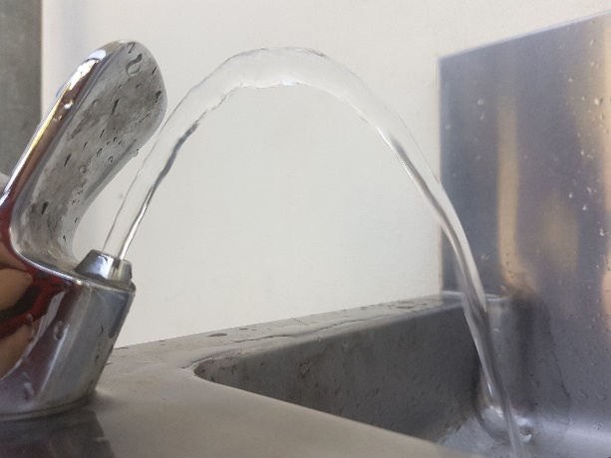

This was achieved by ensuring that the camera was square to the stream, the photo included the water from the origin to the sync.

1. The photo was then printed and by using graph paper the following points were added to the cartesian plane (figure 2)

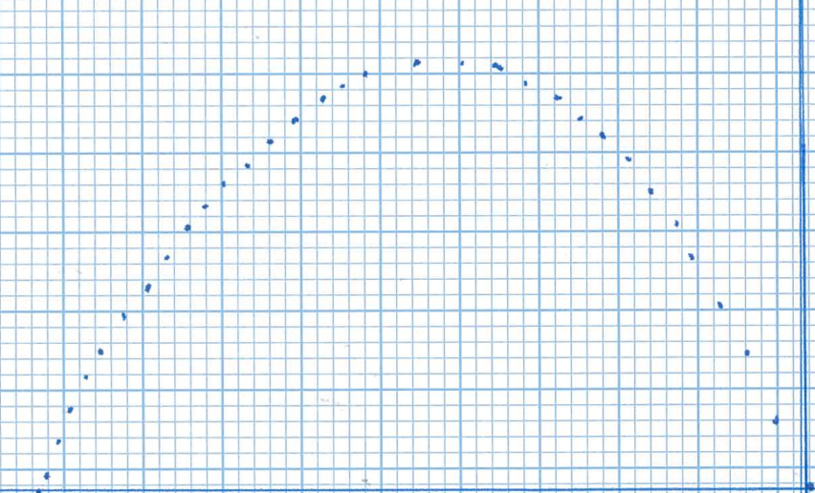

1. By inspecting the dots on the page, a list of coordinates was created (table 1)

|  |  |  |  |  |
| --- | --- | --- | --- | --- |
| x | y |  | 27.5 | 25 |
| 0 | 0 |  | 28.5 | 24.5 |
| 2 | 4 |  | 30.5 | 23 |
| 4 | 8 |  | 32 | 22 |
| 5.5 | 11 |  | 33.5 | 20.5 |
| 7.5 | 14.5 |  | 35 | 19 |
| 8 | 16.5 |  | 36 | 17.5 |
| 10 | 18.5 |  | 37 | 16 |
| 11.5 | 20.5 |  | 38.5 | 14.5 |
| 13 | 22 |  | 39.5 | 12.5 |
| 14.5 | 23 |  | 41 | 11 |
| 16 | 24.5 |  | 42.5 | 8.5 |
| 18 | 25.5 |  | 43.5 | 7 |
| 20 | 26.5 |  | 44.5 | 5 |
| 21.5 | 27 |  | 45 | 3 |
| 23 | 26.5 |  | 45.5 | 1 |
| 26 | 26 |  | 46 | 0 |

1. Using the turning point form of a quadratic and algebra the following function was created
2. Using Excel and the table of points a chart was created and a quadratic and quartic function with r2 values

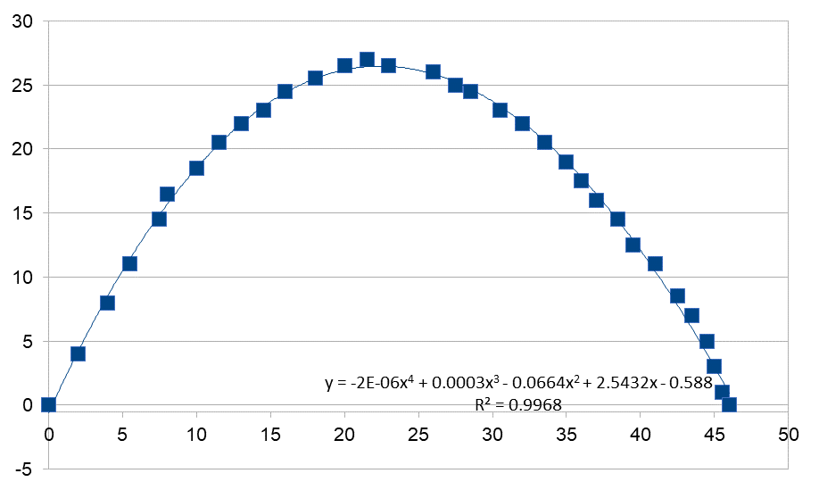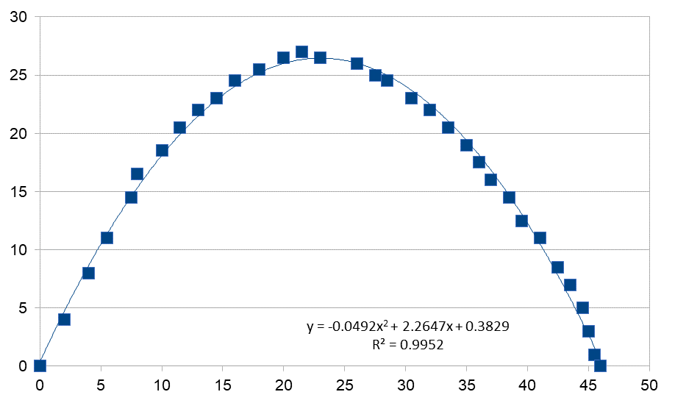

1. Using demos, I inputted the list of coordinates and functions created by steps 5 and 4

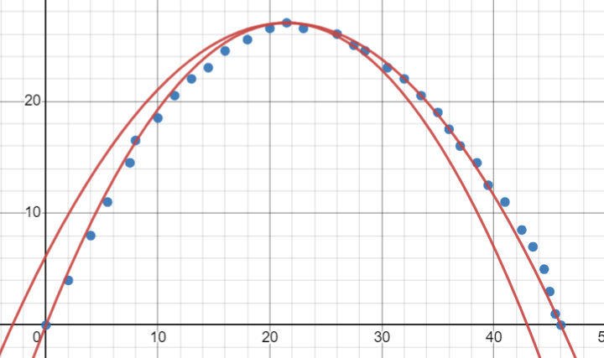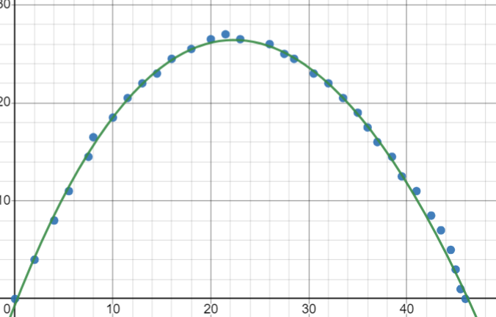

The solution which matches closest to the water bubbler was the quartic created by the trendline feature of Microsoft Excel

This is the most valid solution because it was the largest correlation value and therefore matches the closest to the true line created by the water spout

**Evaluate**

|  |  |
| --- | --- |
| **Assumption** | **Evaluation** |
|  |  |
|  |  |

|  |  |
| --- | --- |
| **Observation** | **Evaluation** |
|  |  |
|  |  |

**Conclusion**